27th October 2016

**YOKOHAMA CONTINUES FOCUS ON TYRE SAFETY**

The Japanese Tyre manufacturer YOKOHAMA, continues its efforts in support of safer tyres and safety on the roads. Following the achievement having received the prestigious Tyresafe Charity Association UK-Tyre Manufacturer of the year Award earlier this year - in recognition of its efforts and innovative approach in promoting tyre safety in the UK, YOKOHAMA is once again supporting Tyresafe in its now popular October campaign.

Throughout the month a number of activities are organised throughout the United Kingdom with a view to create awareness and educate the general road users into the importance of tyre safety, caring for their tyres, checking tyre air pressure and tread depth and ensuring these checks are conducted routinely to make driving a safer experience for all.

Additionally the high profile partnership it shares with Chelsea FC and the recent incorporation of the London Football Club also committing itself to support Tyresafe objectives as a member, has boosted the Tyresafe campaigns.

At the recent Premier league match between Chelsea FC and Manchester United, at Stamford Bridge, this provided the perfect opportunity to reach to over 80,000 fans with messages and reminders on the importance of checking the condition of tyres. Chelsea FC conveyed the messages around the electronic advertising around the pitch as well as the giant video screen in the stadium and within the match day programmes.

“The high-profile tyre safety messages at Stamford Bridge during October have been a timely reminder for thousands of fans attending the games,” stated David Seward, managing director of YOKOHAMA in UK. “We would like to congratulate and thank Chelsea FC for its efforts and hope that as a result of the activity, more drivers heed the advice and give their tyres a thorough examination at this important time of the year.”

Established in 1917, YOKOHAMA is Japan’s oldest tyre manufacturer and one of the world’s largest tyre manufacturers producing a wide range of premium tyres which are selected as OE fitment by a growing number of vehicle manufacturers including Audi, Lexus, Mercedes-Benz and Porsche.

For more information on Tyresafe please visit ; [www.tyresafe.org](http://www.tyresafe.org)

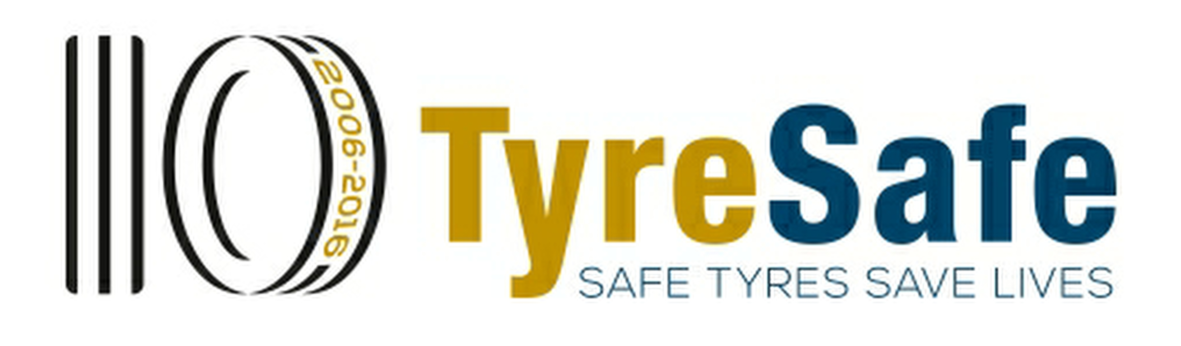

*TyreSafe*